Prayer Journal

This cover page is the final task of the course.
A cover for your journal that represents the specific content of this Journal.
Design a cover page including quotes & illustrations that appear elsewhere in this journal and your name.
The cover requires an artist’s statement. Why you have chosen to present the material in the way that you have and what tis says to you about Christian Prayer and Meditation

The completed journal will be uploaded towards the end of the course by each person.

Contents
This table will update automatically if you don’t change the headings. Right click and choose “Update field” choose “Update entire table.”

Contents 2
List of Illustrations 2
Individual Assessment Task 2
Spiritual Direction 3
Unit Dates 4
What is Prayer? 5
Five Christian Spiritualties 8
My Personality Type and the Christian Spiritual Tradition 9
Reflection Questions for each Prayer Experience 10
Details of Our Group Prayer 11

List of Illustrations
When you add labelled images, right click to add a caption and you can automatically produce a list as follows:
This table will update automatically. Right click and choose “Update field” choose “Update entire table.”

Figure 1 Easter Candle: the paschal candle is lighted for the first time on the evening of the Easter Vigil, when people coming into the Church are baptized. Used a baptisms through the year. 7
Figure 2 A tabernacle is a fixed, locked box in which the Eucharist (consecrated communion hosts) is "reserved" (stored) 7

Individual Assessment Task

Submit your journal showing that you have:

- A record of each prayerful activity in which you have participated, including your personal - reflection upon the nature and value of such an activity.
- Your research into five Christian Spiritual Traditions
- Your more detailed research into the spiritual tradition that is indicated by your personality type
- A complete copy of your group prayer
- A cover for your journal that represents the specific content of the Journal.

Your journal might include ideas/prayers/thoughts. It can be as artistic and individualistic as you like but remember, it must be submitted for assessment at the end of the course.

Spiritual Direction
by Mary Cresp RSJ
Today, more than ever, Christianity must listen anew to the call to “create communities of peace” as sign and instrument of God’s reign, especially as outlined in St Paul’s Letter to the Romans.
In this letter, St Paul urges the disciples to create “attitudes of peace and harmony towards the outside which are the same as to those within the faith community.” This calls for the development of a spirituality that is aware of God’s presence in the whole of life, and the integration of faith and justice at the private and public levels.
Hence the importance of spiritual formation.
In spiritual formation, people are accompanied on their journey of faith and enabled to recognise the action of God in their lives. It is a ministry with ancient roots, going as far back as the early Church where Christians sought out hermits and others known to be close to God, for advice and a “listening ear”. Medieval mystics likewise were pursued by those wanting to develop the spiritual aspect of human life.
Christianity has a rich tradition of spirituality, but in this pluralistic and materialistic age where constant noise bombards our senses, it is a tradition largely unknown and ignored.
In answering the spiritual thirst of our society, spiritual directors play a vital part in the life of the Church, whose mission is that of God who has made us for union, with our Creator, with each other and with the whole of creation. The outer and inner worlds, as described by St Paul, can then become one – we engage in building communities of people

Unit Dates
Keep this contents page for the record of what has happened in the course.

Date | Week | Period | Work
Introduction: What is prayer? I-THOU
Who am I? Who is God? What sort of God do we pray to?
Lectio Divina

Making Time – Sr Joan Chittister
Sample Meditation - Deepest Human Concerns (Meditation)
Does prayer make a difference I?
Sample Mediation: Feelings
Does prayer make a difference II?
What is Prayer? Prayer defined!
Kataphatic Prayer
Sample Prayer “Newness”
 |  |  | Apophatic Prayer
 |  |  | Group preparation time
 |  |  | Group preparation time
 |  |  | TA Day
Christian spiritualties
- Thomistic,
- Augustinian
- Ignatian,
- Franciscan
- Benedictine
My individual prayer type and Temperament
Group preparation time
Christian Unity Prayer
Identifying Prayer types: Forgiveness; Thanksgiving; Petition; Supplication; etc
Online Learning
Identifying Prayer types Revised
Kataphatic prayer – Symbols in the Roman Catholic Church
 |  |  | Kataphatic prayer – Symbols in the Roman Catholic Church
 |  |  | All prayer journals to be submitted electronically.
 |  |  | Final class of term

What is Prayer?

Prayer is ….

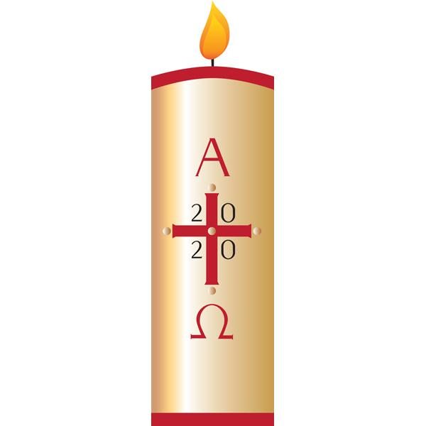
Figure 1 Easter Candle: the paschal candle is lighted for the first time on the evening of the Easter Vigil, when people coming into the Church are baptized. Used a baptisms through the year.

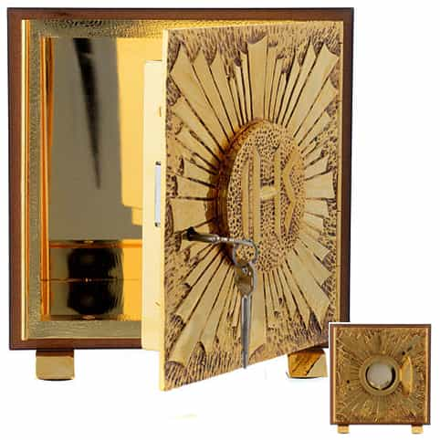
Figure 2 A tabernacle is a fixed, locked box in which the Eucharist (consecrated communion hosts) is "reserved" (stored)
Types of Prayer

Kataphatic prayer:

Write you own understanding of this here…..

Apophatic Prayer

Write you own understanding of this here…..

Five Christian Spiritualties

This is where you find and insert a summary or description of the various Christian Spiritualties, including a little on their history and key figures involved.

Thomistic, Augustinian, Ignatian, Franciscan, Benedictine

My Personality Type and the Christian Spiritual Tradition

This is where you insert the information about the Jungian Personality Type and the results of your research into your spirituality type including prayer styles suited to your type.

- State your personality (from term 1 e.g. ISTJ)
- -Which prayer type do you come under?
  - Thomistic, Augustian, Ignatian, Fransician (Check the notes you made at the beginning of term)
- find out about the temperament of your prayer type e.g. Thomistic
- find a prayer that is characteristic of your personality/prayer type
- find a gospel story that supports your prayer type
Keep a list of your sources

Reflection Questions for each Prayer Experience

What was the prayer intending?
What image of God was presented in this prayer?
What was my reaction to this?
What resources and ideas were used in this prayer and why?
How did this prayer make you feel?

This is where you will write the reflections. Use this template.

Date | Presenter/s | Theme
xxxxx | xxxxx | xxxxx
Reflection
What was the prayer intending?
xxxxx
What image of God was presented in this prayer?
xxxxx
What was my reaction to this?
xxxxx
What resources and ideas were used in this prayer and why?
xxxxx
How did this prayer make you feel?

Details of Our Group Prayer

This is the place to put a copy of your prayer that you led.

https://re12prayer.weebly.com/

